**Creation of Project and Handling Service Requests on JIRA Service Management and JIRA Software**

I did this project on solo basis. So, the working is all done by me.

First, we will create project on JIRA and this project will have IT operations and Software Development team.

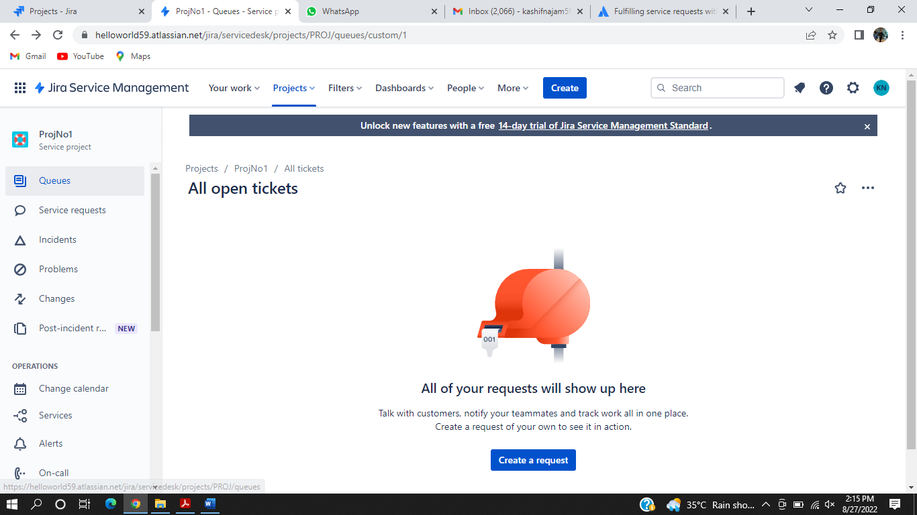

Then we will create first service request in which a member of the software development team is requesting a guest Wi-Fi access because he needs to test the build on a personal device which is not authorized as the official device on service.

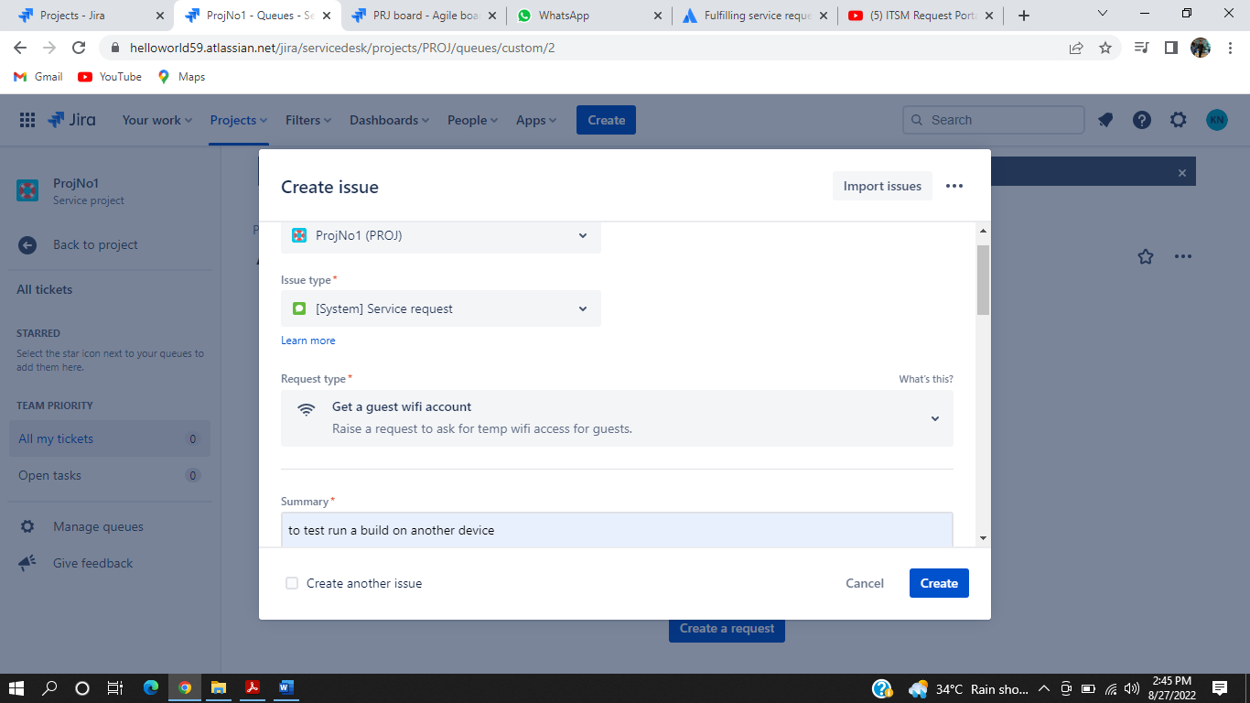

The request has been issued and is in waiting list for the response from support.

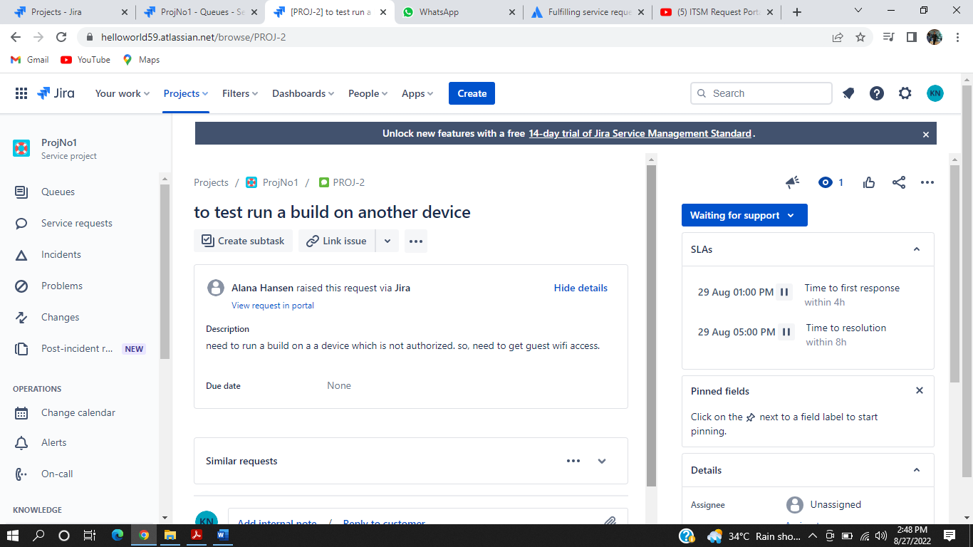

Then the support has responded and now waiting for the response from the software development team.

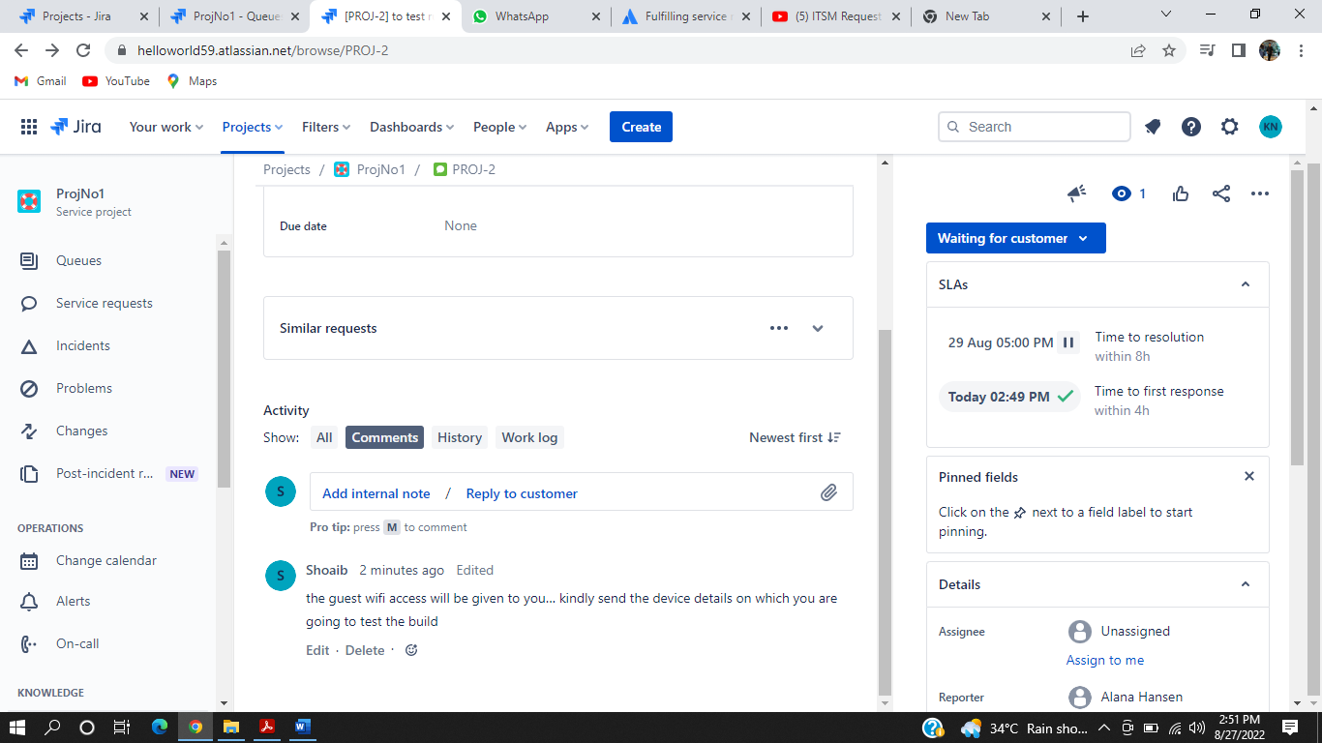

The request has been escalated and now is in the progress stage of the request and is now being processed.

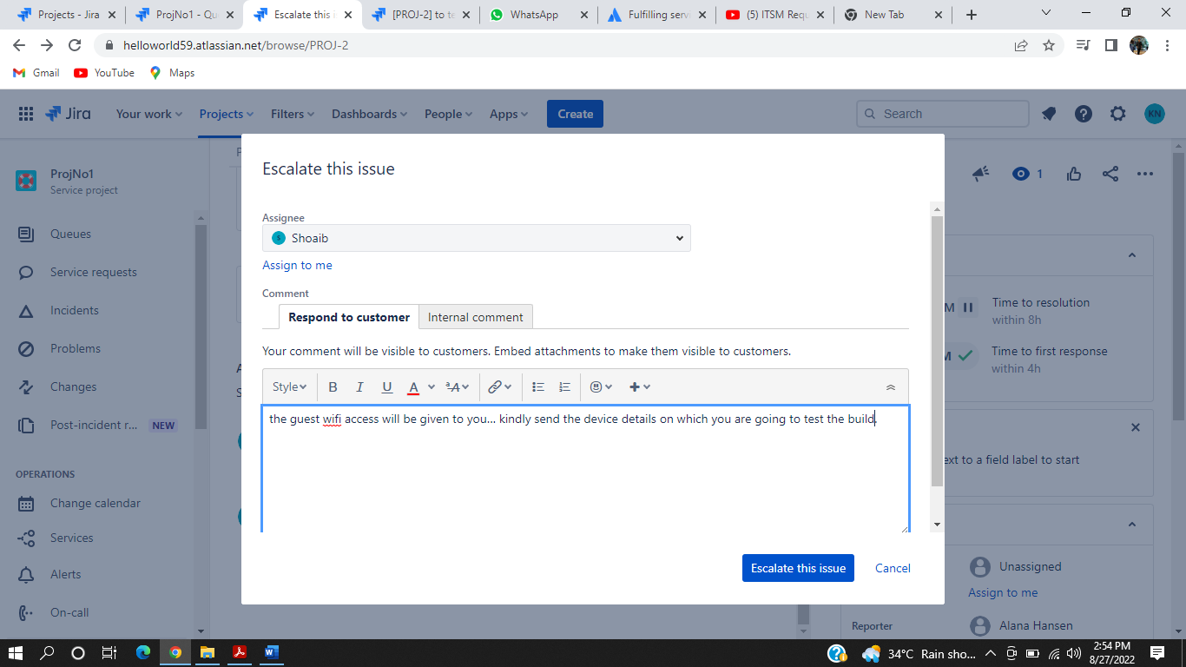

As you can see in the snapshot below that the request is in the progress state.

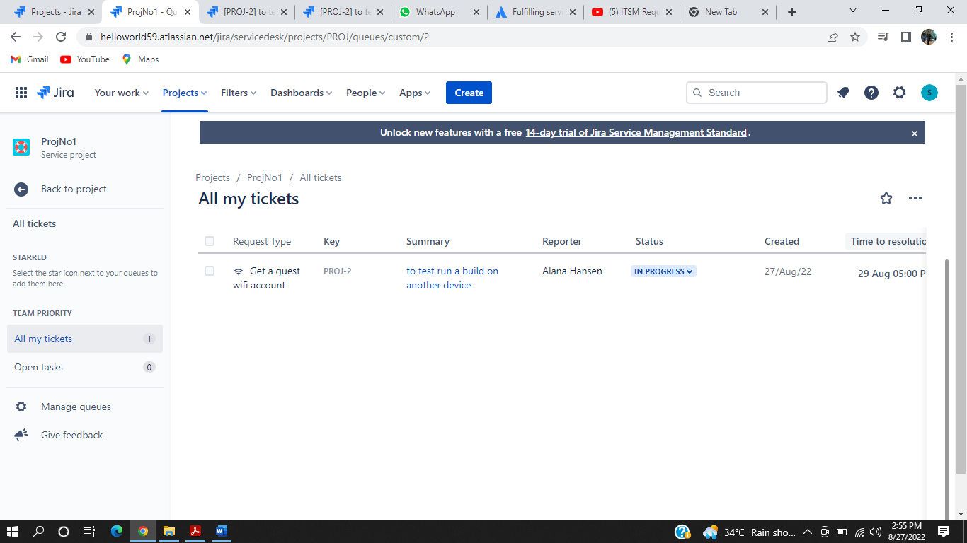

Now the request has entered in the resolving stage which means that the IT operations team have resolved the request and marked as DONE.

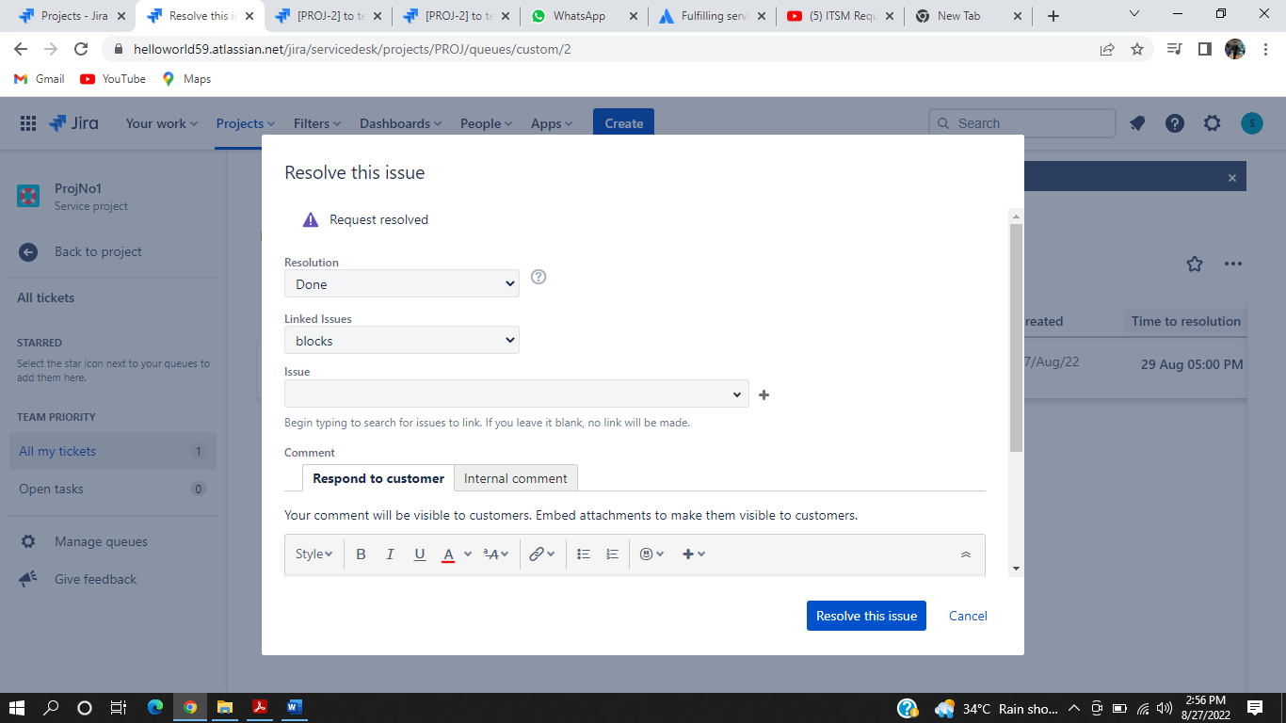

The snapshot below is showing that the request has been resolved.

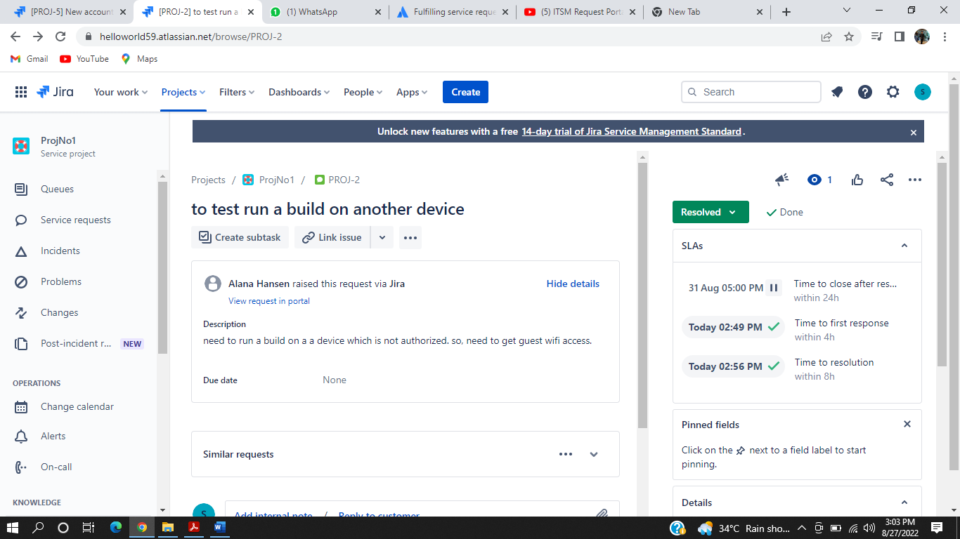

Now the other 2 service requests are being given by the software developer team and will be handled by IT operations.

The snapshot below is showing that another request which in JIRA is called an issue, is being added by the software developer team.

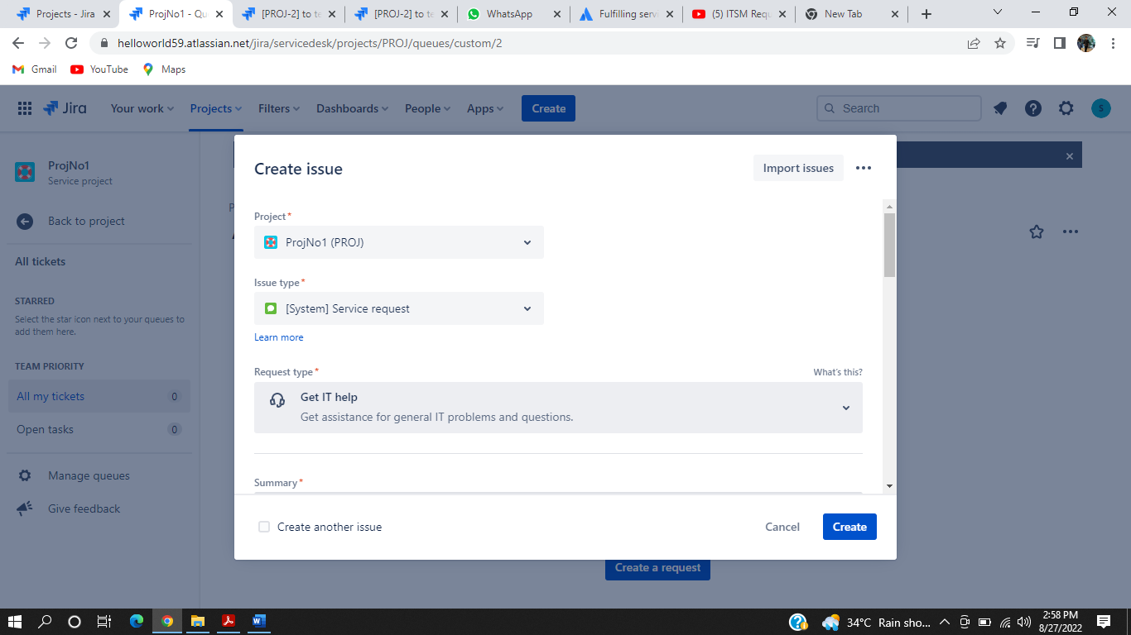

Now in the snapshot below, we can see that there are 2 more service requests. The first one is requesting for a new account for the new member that has been added to team. The second request is showing that one of the developer’s system is not working properly and he wants to fix it as soon as possible so that he can start working again.

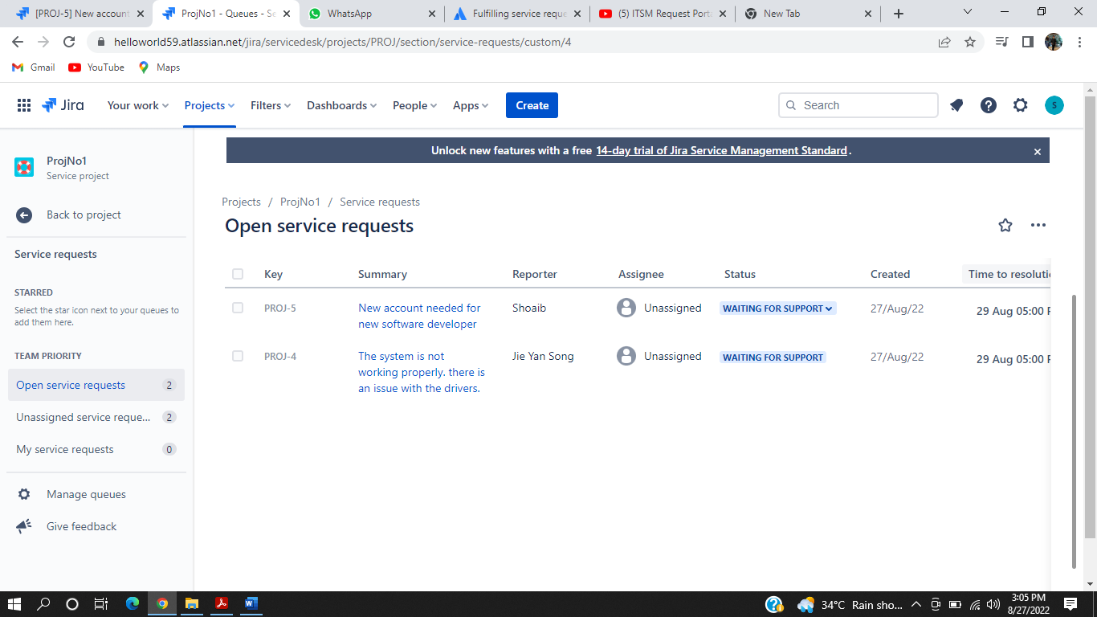

The support is replying for the PROJ-4 request by informing it that there is an issue with the system hardware not software, and they are requesting a new system request from the administrator.

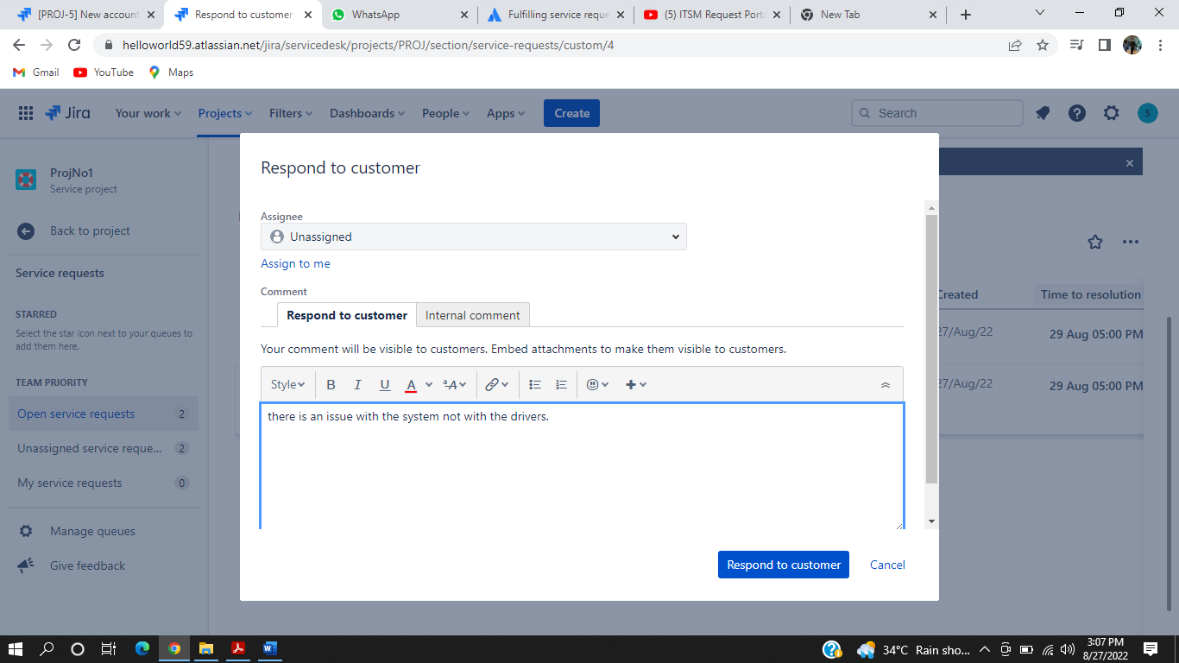

Now we can see in the snapshot below that the first request is still in waiting for the response from the support and the second request has been answered by the technical team.

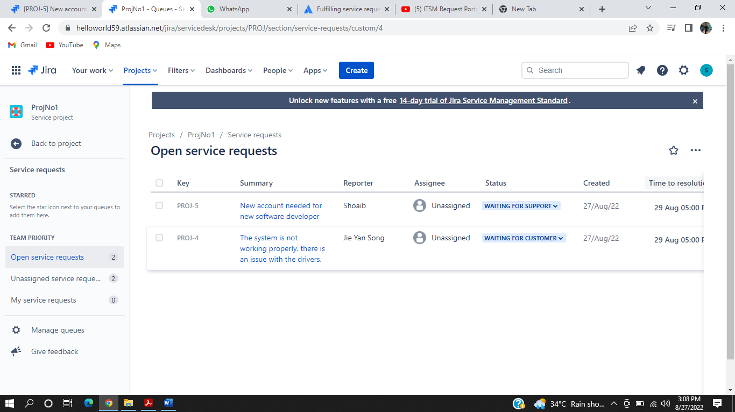

Now the IT team is responding to the Software development team and they are telling them to wait so that they can get permission from the administrator and the request is in pending stage.

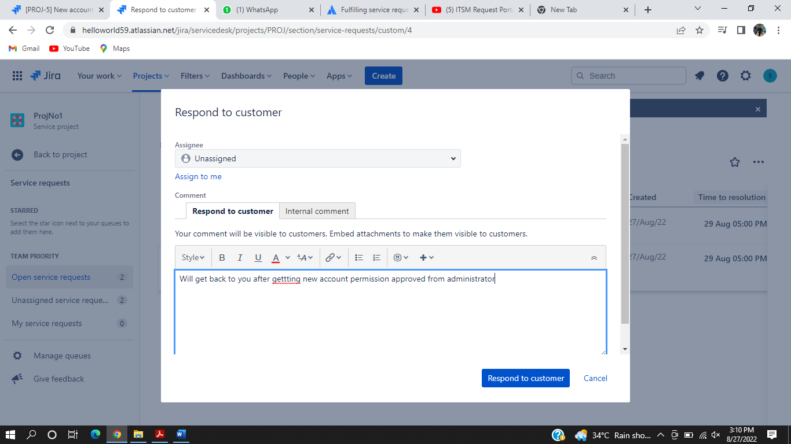

The request has been pushed to the processing stage as the request for new account has been approved.

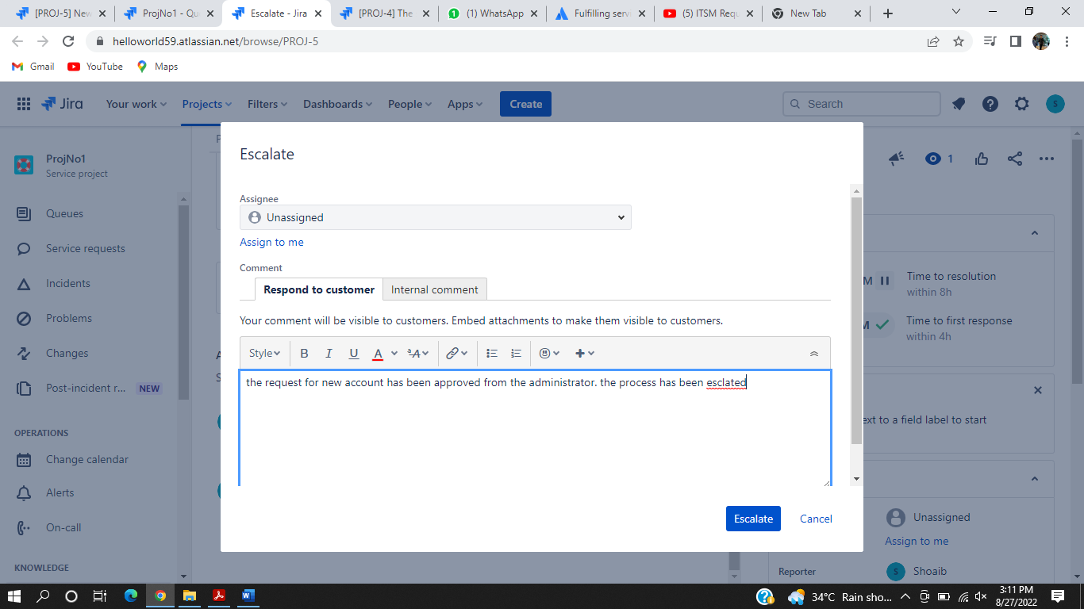

The request for the repairing of the system has been cancelled by the IT team as the did not get approval from the administrator to replace the desktop. So, the request has been cancelled.

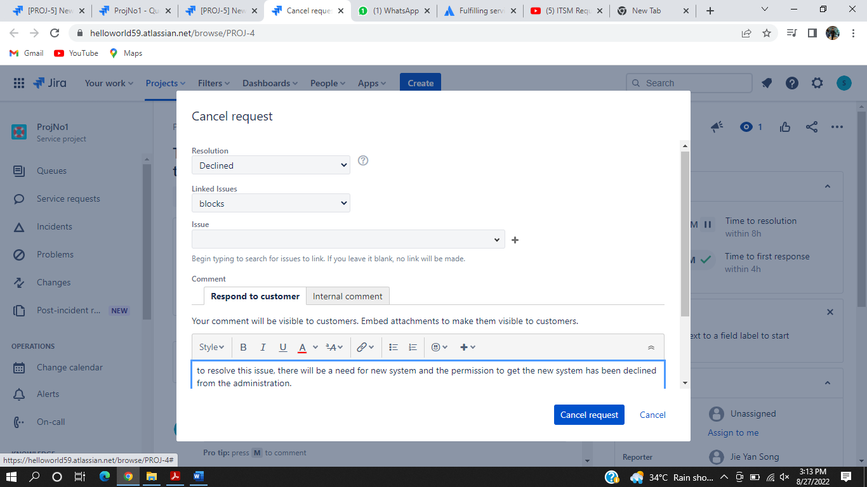

As one request has been cancelled, that is why only a single request is left in the service request panel.

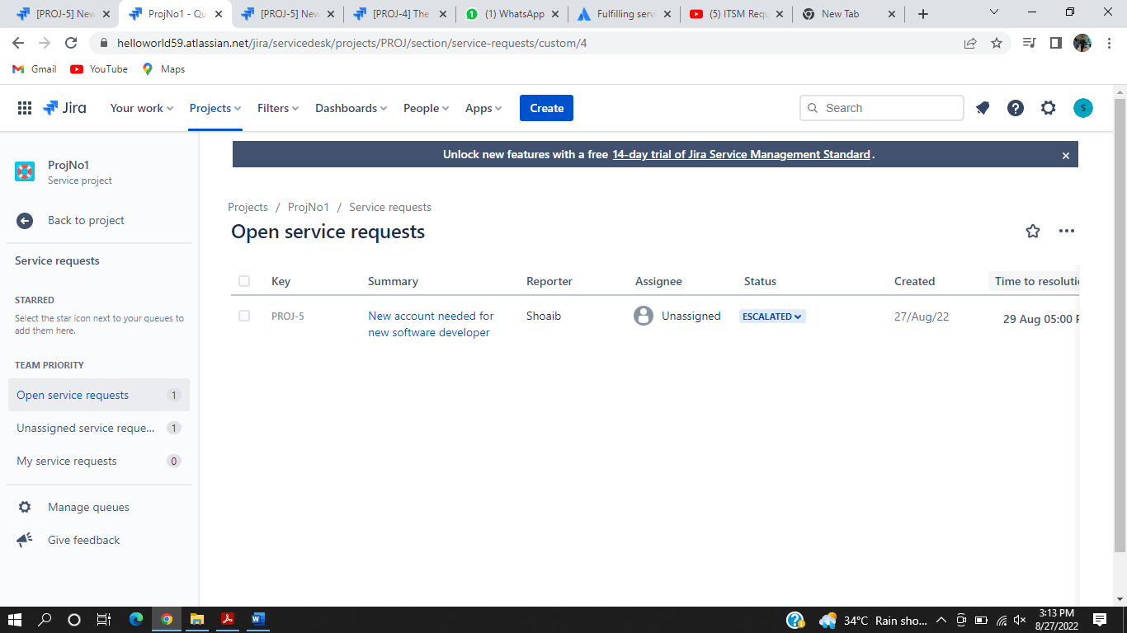

The last request for the creation of new account has been resolved and the account is created by the IT operations team with the organization’s name as the reference.

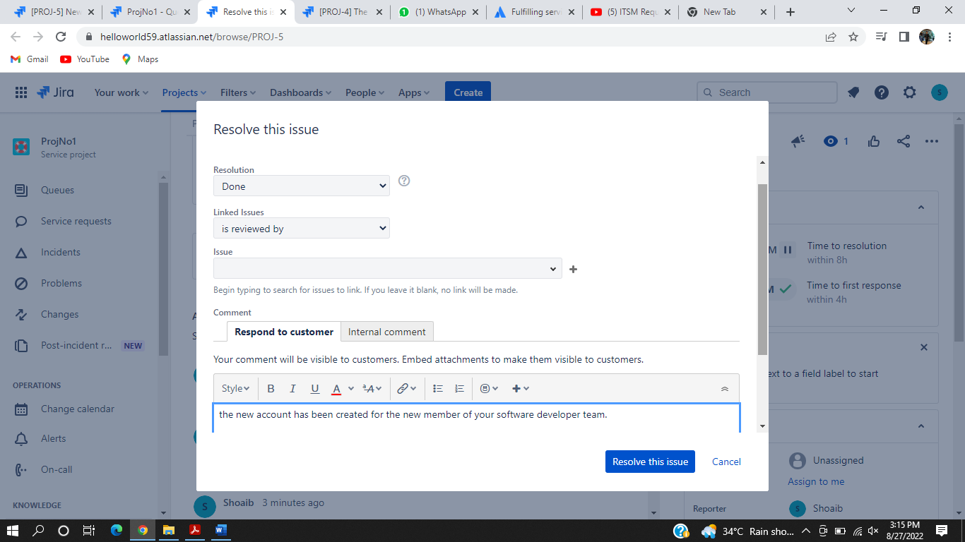

As all the requests have been either resolved or cancelled so there is no query left on the panel as we can see in the snapshot below.

